Assessment type ():
☐ Questioning (Oral/Written)
☒ Practical Demonstration
☐ 3rd Party Report
☐ Other – Project/Portfolio (please specify)

Assessment Resources:
You are provided with:
Development Environment Options:
Kaggle (connected from VSCode to your running Kaggle session), or
Azure GPU VM via SSH from your local VSCode
PyTorch 60-Minute Blitz Tutorial as conceptual guide: https://pytorch.org/tutorials/beginner/deep_learning_60min_blitz.html
Sample PyTorch training scripts (provided in class)
Experiment tracking tools: Weights & Biases, MLflow, or manual CSV/JSON logging
Distributed training frameworks: Hugging Face accelerate or PyTorch torchrun
Access to NMTAFE GitHub repository for code/artefact submission
Template for README.md (provided in class LMS)
Links to Documentation:
PyTorch Distributed Training
Hugging Face Accelerate
Weights & Biases Quickstart
MLflow Tracking

Assessment Instructions:
Overview
In this assessment, you will build a professional PyTorch training workflow that demonstrates competency in scripting, automation, and documentation. You will create a complete training script with experiment tracking, then develop a distributed launcher for multi-GPU execution. This assessment focuses on code quality, reproducibility, and professional documentation standards.
Instructions
Complete both parts in sequential order. Record all relevant outputs as code files, logs, screenshots, and written documentation as instructed.
You must complete all tasks to a competent standard to pass this assessment. Partial completion will result in a 'Not Yet Competent' (NYC) outcome.
Submission Evidence:
Complete train.py script with all required features
Working run_distributed.sh launcher script
Comprehensive README.md with setup and usage instructions
Evidence folder with logs, screenshots, and artifacts
Requirements.txt or environment documentation
Submission Method:
Collate all materials into a single zip file or private GitHub repository as directed by your lecturer.
Submit via the class LMS or as instructed.

Assessment Instrument:
Part A: Training Script with Experiment Tracking (Single GPU/CPU)
Unit Links:
ICTPRG435: 1.1, 1.2, 2.1, 2.2, 2.3, 3.1, 3.2, 3.3, 3.4, 4.1, 4.2, 4.3
Objective:
Create train.py that implements a clear, reproducible training workflow for PyTorch models.
Required Features:
a) Data Loading and Processing:
Implement Dataset/DataLoader or use a torchvision dataset (e.g., MNIST/CIFAR-10)
Print first batch shape for verification
Handle data preprocessing and augmentation appropriately
b) Model Architecture:
Create nn.Module with clear layer names and documented forward method
Implement appropriate model for the chosen dataset
Include model summary or parameter count
c) Device and Optimization Setup:
Use device = torch.device('cuda' if torch.cuda.is_available() else 'cpu')
Move model and data batches to appropriate device
Define optimiser (e.g., Adam) and loss function (e.g., CrossEntropyLoss)
d) Training Loop Implementation:
Implement complete training loop: zero grads → forward → loss → loss.backward() → optimizer.step()
Log epoch loss and at least one metric (e.g., accuracy)
Include progress tracking and validation
e) Evaluation and Metrics:
Implement evaluation loop with torch.no_grad()
Compute at least one metric (e.g., accuracy, precision, recall)
Include confusion matrix for classification tasks
f) Checkpointing and Model Persistence:
Save and load model state_dict
Demonstrate short inference with reloaded model
Implement best model saving based on validation metrics
g) Reproducibility:
Set random seeds for all random operations
Note package versions in requirements.txt
Specify any deterministic flags used
h) Experiment Tracking (Choose One):
Weights & Biases (recommended): Log loss/metrics, config, and artifacts
MLflow: Log params, metrics, and model file
Manual CSV/JSON: Create structured log files if trackers unavailable
i) Command Line Interface:
Provide sensible arguments: --epochs, --batch-size, --lr, --data, --output-dir, --tracker {wandb,mlflow,none}
Include help text and argument validation
Evidence Checklist for Part A:
[ ] train.py script with all required features implemented
[ ] Screenshot of successful single-GPU/CPU training run
[ ] Training logs showing loss/metrics over epochs
[ ] Experiment tracking screenshots (W&B/MLflow) or CSV/JSON logs
[ ] Confusion matrix or evaluation metrics output
[ ] Model checkpoint file(s)
[ ] Short inference demonstration with reloaded model
[ ] Requirements.txt with package versions

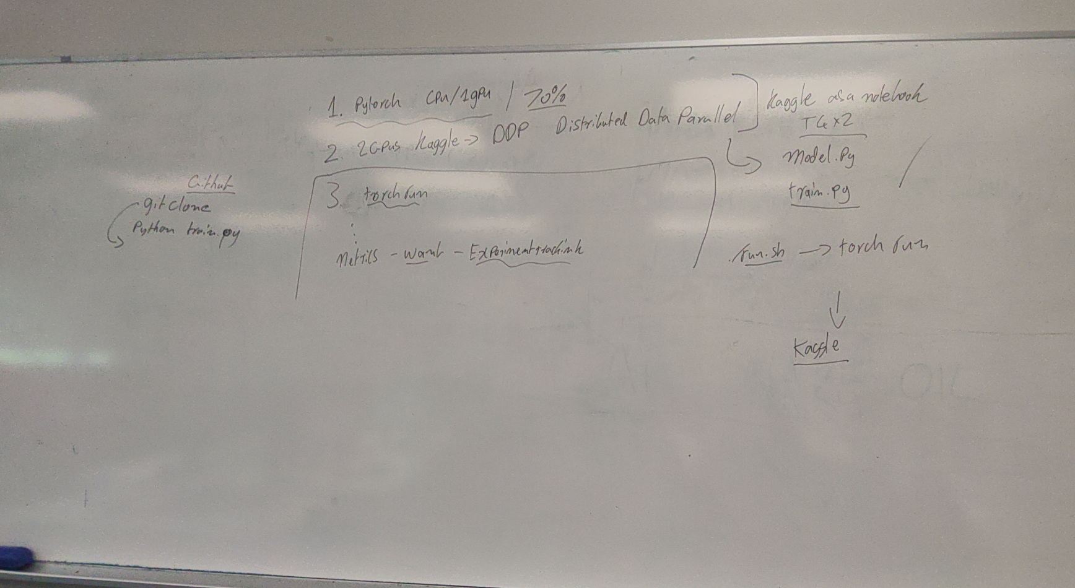

Part B: Distributed Launcher via Bash (Multi-GPU)
Unit Links:
ICTPRG435: 2.1, 2.2, 2.3, 3.1, 3.2, 3.3, 3.4, 4.1, 4.2, 4.3
Objective:
Create run_distributed.sh that launches train.py with multi-GPU using either accelerate or torchrun.
Choose ONE Implementation Path:
Option 1: Hugging Face Accelerate
Include non-interactive default configuration or flags in the script
Example command: accelerate launch --num_processes 2 --mixed_precision fp16 train.py --epochs 5 --batch-size 128 --lr 1e-3 --tracker wandb
Option 2: PyTorch Torchrun
Example command: torchrun --nproc_per_node=2 train.py --epochs 5 --batch-size 128 --lr 1e-3 --tracker wandb
Script Requirements:
a) GPU Detection and Fallback:
Detect available GPU count automatically
Fall back to single-process if only one/no GPU available
Provide clear messaging about detected hardware
b) Argument Handling:
Accept pass-through args to train.py (e.g., ./run_distributed.sh --epochs 10 --batch-size 64)
Validate arguments and provide helpful error messages
Include sensible defaults for common parameters
c) Logging and Output:
Emit short run header (device info, world size, configuration)
Write logs to runs/ directory with timestamps
Provide clear progress indicators
d) Error Handling:
Handle common errors gracefully (e.g., CUDA out of memory, missing dependencies)
Provide troubleshooting guidance in error messages

Evidence Checklist for Part B:
[ ] run_distributed.sh script with all required features
[ ] Screenshot of multi-GPU launch (or graceful single-GPU fallback)
[ ] Terminal output showing device detection and configuration
[ ] Tracker screenshots comparing at least two runs with different hyperparameters
[ ] Log files from distributed training runs
[ ] Evidence of pass-through argument functionality

Part C: Documentation and Environment Setup
Unit Links:
ICTCLD401: 4.1, 4.2, 4.3
Objective:
Create comprehensive documentation and demonstrate environment setup proficiency.
Environment Pathways (Choose One):
Option 1: Kaggle via VSCode
Start a Kaggle notebook with GPU enabled
Use VSCode to connect to the running Kaggle session (Remote/Tunnel)
Install dependencies inside the session and run the scripts
Option 2: Azure VM via SSH
Provision a GPU VM, SSH from VSCode, and install CUDA-compatible PyTorch
Run python train.py and ./run_distributed.sh from the VM shell
Documentation Requirements:
a) README.md Content:
Clear setup instructions for chosen environment (Kaggle or Azure)
Sample commands with expected outputs
Troubleshooting section for common issues
Environment requirements and dependencies
b) Code Documentation:
Inline comments explaining key sections of code
Function and class docstrings
Configuration explanations
c) Evidence Organization:
Well-structured evidence folder
Clear labeling of all screenshots and logs
Mapping statement linking work to UoC criteria
Evidence Checklist for Part C:
[ ] Comprehensive README.md with setup and usage instructions
[ ] Screenshots of environment setup (Kaggle or Azure)
[ ] Evidence of dependency installation and configuration
[ ] Well-organized evidence folder with labeled artifacts
[ ] Mapping statement in README linking work to UoC criteria
[ ] Code documentation and inline comments

Assessment Checklist
Success criteria for a Competent (C) result:
Complete train.py script with all required features (data, model, training, evaluation, tracking)
Working run_distributed.sh launcher with GPU detection and fallback
Comprehensive README.md with clear setup and usage instructions
Evidence of successful single-GPU and multi-GPU training runs
Professional code quality with appropriate documentation and error handling
All evidence properly organized and labeled
Student can explain/defend choices if questioned by lecturer (in-class Q&A)
Not Yet Competent (NYC) Indicators:
Missing or incomplete training script functionality
Non-working distributed launcher or missing fallback logic
Incomplete or unclear documentation
Missing evidence of successful training runs
Poor code quality or lack of error handling
Unorganized or unlabeled evidence

Industry and Workplace Context
This assessment reflects industry practice in developing reproducible machine learning workflows with proper experiment tracking and distributed training capabilities. All components align with real-world job requirements for ML Engineers and Data Scientists, including code quality standards, documentation practices, and automation skills.
By completing this assessment, you will demonstrate entry-level competence in PyTorch development, scripting automation, and professional documentation, directly supporting employability and career progression in machine learning and artificial intelligence engineering.

Marking Checklist
Part A - Training Script | S/NYS
Student implemented complete PyTorch training script with all required features
Training script runs successfully on single-GPU/CPU with experiment tracking
All required components are present (data loading, model, training loop, evaluation, checkpointing)
Code demonstrates professional quality with appropriate error handling
Part B - Distributed Launcher | S/NYS
Bash script successfully launches multi-GPU training (or demonstrates graceful fallback)
Script includes GPU detection, argument handling, and error management
Evidence shows successful distributed training runs or appropriate fallback behavior
Pass-through arguments and logging functionality work correctly
Part C - Documentation | S/NYS
README.md provides comprehensive setup and usage instructions
Environment setup evidence is clear and complete
Code documentation includes inline comments and docstrings
Evidence folder is well-organized with labeled artifacts
Evidence Quality | S/NYS
All required screenshots, logs, and artifacts are provided
Training logs show successful completion with metrics
Experiment tracking evidence demonstrates proper logging
Model checkpoints and inference demonstrations are included
Professional Standards | S/NYS
Code follows best practices and is well-structured
Documentation is clear, professional, and complete
Evidence demonstrates understanding of ML workflow concepts
Student can explain technical decisions if questioned

